Ageing Well:
  - My Midlife Health Story

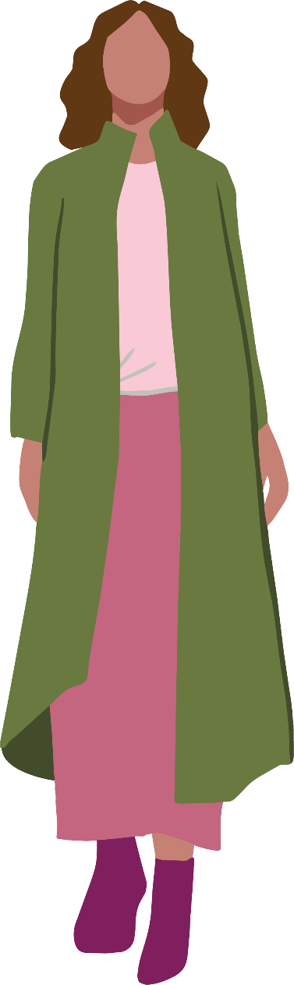
Note: We understand that every woman and gender diverse person's experience of health is different. Within this booklet we have endeavoured to ensure the information provided is relevant for our community, however we acknowledge that the content may not be reflective of all experiences. Please note that this booklet uses a first person narrative to communicate health information and is not the depiction of any specific individual's experience.

Table of Contents
We all age 2
My midlife wake‑up call 2
Living My Best Midlife Life 3
Nutrition: What I’ve Learnt 4
Physical Activity: How I Found What Works for Me 5
Social Connection: A Lifeline I Didn’t Expect 6
Health Checks: Taking Charge of My Own Health 7
Planning for the Future 8
References 9
Access This and Other Resources Online 9
Stay In Touch 9

We all age
But I’ve learned that staying active and having a healthy lifestyle makes a huge difference in how I age, physically, mentally, and emotionally.

My midlife wake‑up call
Ageing is a natural part of life, but if I’m honest, I didn’t really start paying attention to my “midlife health” until my mid‑40s.
I still remember the moment it hit me: I was walking up the stairs at home (like I do everyday), but this time I had to stop halfway to catch my breath. And for the first time, I thought, “Maybe my body needs me to find some extra ways to support it now.”
Here in Gippsland, over a quarter of women are aged 45–641. Knowing I’m part of this big group of women moving through the same stage of life makes me feel less alone, and more motivated to take charge of my health.

Living My Best Midlife Life
Like all phases of life, having a healthy lifestyle matters. But in midlife, I’ve noticed that small habits suddenly have a bigger impact.
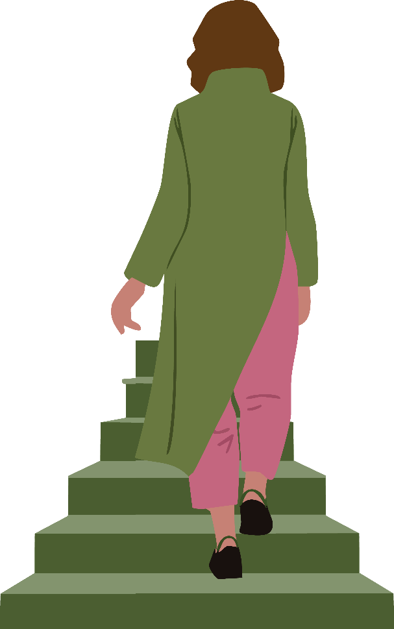

Nutrition: What I’ve Learnt
I used to think nutrition was mostly about weight. Now I know it’s about energy, bones, muscles, digestion, and long‑term health2.
After one too many afternoons where I hit a wall around 3pm, I realised I needed to start eating more foods that truly supported me. Since then, I try to focus on hitting my nutrition goals3:
- Calcium, vitamin D & protein – for bone and muscle strength
- Fibre – for bowel and heart health
- Healthy fats – for cholesterol and heart health
The nutrition for women poster also provides more information on different types of food and how they can support my health
It’s not about avoiding eating my favourite foods, I still love my chocolate, but it’s about making sure that I also eat foods that are going to support my body properly.
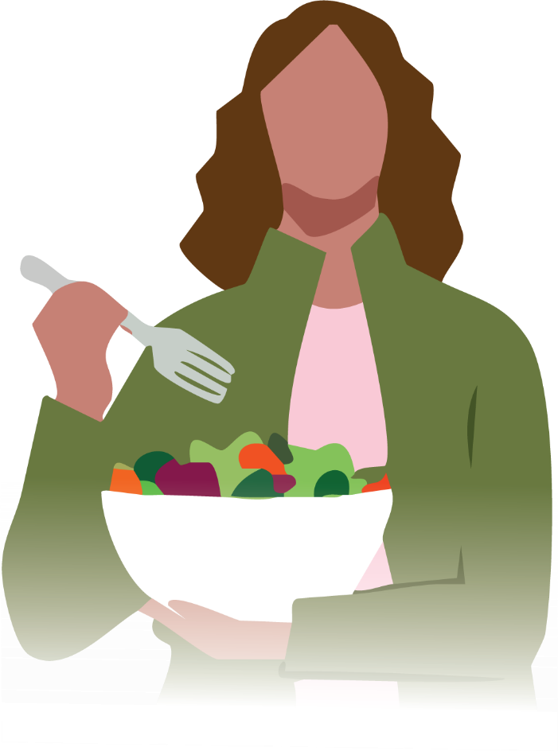

Physical Activity: How I Found What Works for Me
Exercise used to feel like something I “should” do. Now, it feels like something I do to feel good.
Being active helps me with4,5:
- physical strength
- balance (I noticed myself getting clumsier!)
- heart health
- mental wellbeing and staying socially connected
I started small: a friend invited me to a walking group, and even though I was nervous, I went. That simple walk became my weekly “reset button.”
Other activities I’ve tried (and loved)5:
- swimming
- weight training
- gardening (which counts - I was surprised too!)
- dancing in the kitchen
- balance exercises

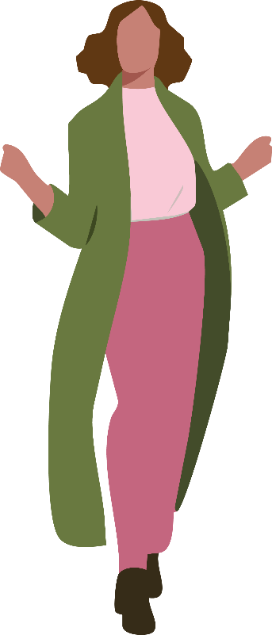

Social Connection: A Lifeline I Didn’t Expect
Midlife can feel isolating. Kids grow up, routines change, friendships shift. There was a period where I felt lonely without realising it. One day, I joined a short community workshop on pottery, and suddenly I found myself laughing with complete strangers.
Ways I’ve connected since then6:
- community groups
- volunteering
- walking groups
- learning a new hobby
- joining short courses
Every time I show up somewhere new, my world gets a little bigger.

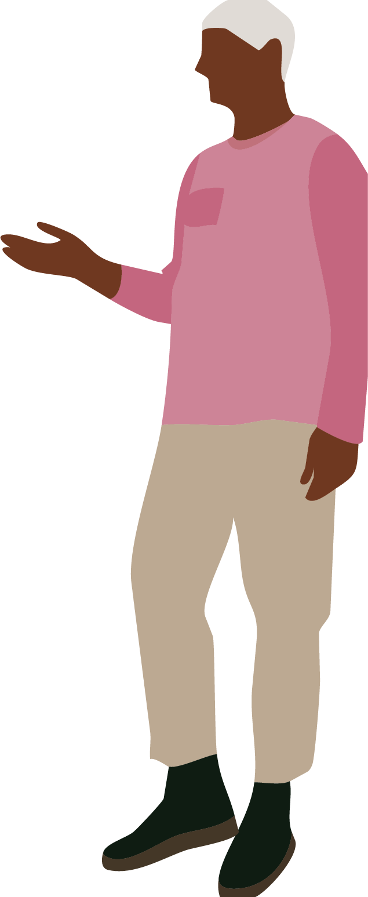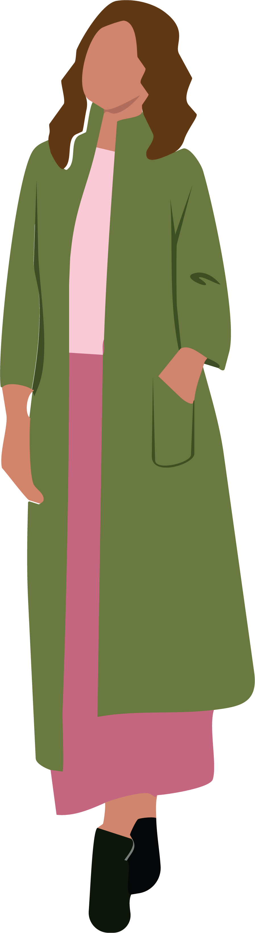

Health Checks: Taking Charge of My Own Health
I used to think health checks were for “older people”, until my GP reminded me that midlife is where prevention matters most. Here’s what I now stay on top of:

Cervical screening
I was relieved to learn there are now two options for screening: a health provider can collect a sample or, I can self‑collect - which made the whole thing easier and less stressful7.

Breast screening
I get my free breast screening every two years now with BreastScreen Victoria (these are available for women aged 50-74 without breast symptoms)8. The BreastScreen Victoria website provides all the information you need.
I also do breast self‑checks at home. The first time I did one, I had no idea what I was looking for but once I learned, it became second nature. The Are You Covered magazine (issue 2) provides a step-by-step guide to performing a breast check (page 10).

Bowel cancer screening
Being aged between 50 and 74 I receive a free bowel cancer kit in the mail every two years (these test kits can also be requested from age 45)9. When the test kit first arrived in the mail, I put it off (twice!). When I finally did it, it was quick and gave me peace of mind.

Ovarian cancer symptom tracking
Because there’s no screening test, I use the Ovarian Cancer Australia symptom diary to record any concerns I have10.

Menopause care
Checking in with my GP about my menopause symptoms was one of the best things I ever did. The Jean Hailes checklist helped me feel prepared instead of overwhelmed.

Other checks I’ve added to my list
- blood sugar
- blood pressure
- cholesterol
- skin checks
- hearing & eye tests
- oral health
- bone health assessment
- falls risk
- STI testing (yes, it still matters!)
- immunisations
When I feel confused about what I should be checking, I use the Jean Hailes Her Health Check tool. It makes everything clearer.

Planning for the Future
I used to avoid thinking about the next phase of life because it felt morbid or “too soon”. But I realised that planning actually gives me control, not fear.
Things I’ve now started organising11:
- keeping important documents together
- preparing my will
- completing an advance care directive
- noting my wishes for future care and talking about these with my loved ones
- starting simple funeral planning
It’s not gloomy - it’s empowering. It’s me taking care of my future self and the people I love.
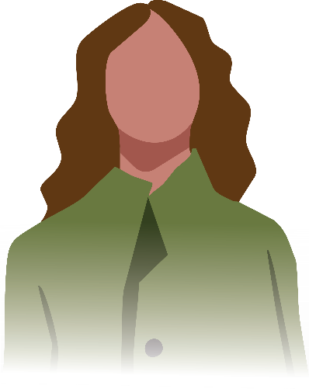

References
- Victorian Women's Health Atlas, Victorian Women's Health Atlas
- The Royal Women's Hospital, Nutrition | The Royal Women's Hospital
- Jean Hailes, Nutrition and healthy eating as you age | Jean Hailes… | Jean Hailes
- Jean Hailes, Exercise And Keeping Active | Jean Hailes
- Jean Hailes, Staying active as you age - Jean Hailes
- Jean Hailes, Staying connected as you age - Jean Hailes
- Cancer Council, Cervical cancer screening | Cancer Council
- BreastScreen Victoria, About Our Program | BreastScreen Victoria
- Bowel Cancer Australia, National Bowel Cancer Screening Program (NBCSP)
- Ovarian Cancer Australia, Ovarian Cancer | Diagnosis and Results
- Cancer Council Victoria, Planning for the end of life

Access This and Other Resources Online
Read this resource online, access alternative formats, or explore other Say Yes To You resources on menopause, heart health and mental health on our website.

Stay In Touch
Follow us on social media
@GippslandWomensHealth
or visit www.gwhealth.asn.au
Contact us: gwhealth.asn.au/contact/

This resource was developed with support from The Latrobe Health Services Foundation.

