My Mental Health Story
  - As a Woman in Gippsland
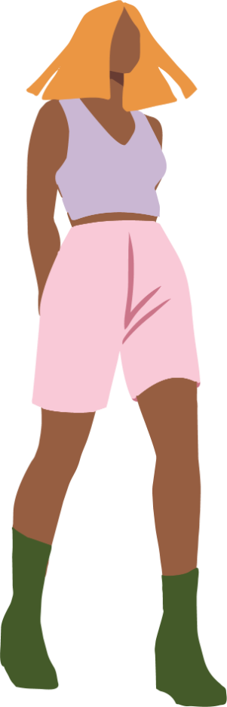

Note: We understand that every woman and gender diverse person's experience of health is different. Within this booklet we have endeavoured to ensure the information provided is relevant for our community, however we acknowledge that the content may not be reflective of all experiences. Please note that this booklet uses a first person narrative to communicate health information and is not the depiction of any specific individual's experience.

Table of Contents
How My Mental Health Has Changed Over the Years 2
Stigma and the Stuff No One Talks About 3
Recognising when I need support 4
Little Things I Do to Take Care of My Mental Health 5
Getting a Mental Health Treatment Plan 6
What it actually is 6
How I got mine 6
Where I Can Go Support in Gippsland 7
References 7
Self-Care Mapping Exercise 8
Access This and Other Resources Online 9
Stay In Touch 9

How My Mental Health Has Changed Over the Years
As a woman, my body has experienced a lot - puberty, periods, pregnancy, perimenopause, menopause… it feels like every chapter comes with its own twists1. And with each of those changes, my mental health has shifted too.
Something I hadn't considered before, was the mental load. It's all the invisible work I do to sort my family's life - like managing the household calendar or making shopping list2. Don't get me wrong I love caring for my family, but I have found this mental work has often fallen to me and I know it's had an impact on my mental health2.
When I found out that around 44% of women in Gippsland have been diagnosed with anxiety or depression, it honestly didn’t surprise me3. I’ve seen so many women around me struggling and I’ve had my own moments too.
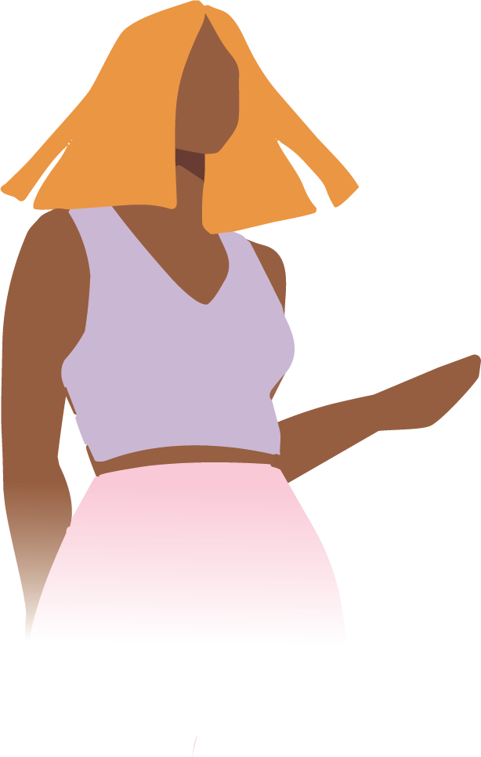

Stigma and the Stuff No One Talks About
I’ll be honest - when my mental health first started slipping, I didn’t tell anyone. I felt embarrassed and didn’t want people to think I was “struggling”4. I kept telling myself I should just toughen up, or that other people had it worse.
But here’s what I wish someone had told me earlier:
My mental health does not define me4.
Struggling doesn’t make me weak, dramatic, or “broken”. And the stigma that surrounds mental health? That’s about misunderstanding and doesn’t represent who I am4.
Reaching out to a GP, a counsellor, or even a friend isn’t something to feel ashamed of4. It’s actually one of the bravest things I can do.

Recognising when I need support
Struggling with mental health looks different for everyone. Being able to recognise when my mental health is not in a good place, helps me know when I need support. For me some of these signs can look like5:
- Withdrawal – when I lose interest in going for my daily walks
- Fatigue and low energy – I begin to feel tired all the time and like I can never get enough sleep
- Restlessness and agitation – feeling anxious a lot more than usual
- Difficulty concentrating – finding it harder to stay focused during activities that are usually simple
When these start showing up a lot in my life, I know it’s time to take steps to better support my mental health.
The Beyond Blue website has further information on the common signs and symptoms of struggling with mental health.

Little Things I Do to Take
Care of My Mental Health
I used to think self‑care meant big gestures, massages, spa days, fancy getaways. And while self-care definitely can include those things, they may not be realistic every day or provide the long-term support you need.
Now, I think of self‑care more like brushing my teeth6. Small things I do regularly to support my wellbeing and fill my cup6.
Some things that can help6:
- Taking five minutes to enjoy a quiet tea or coffee with no phone
- Staying connected with friends, family, or my community
- Doing things I enjoy — trying a new hobby or sport
- Writing down three things I’m grateful for
- Going for a short walk (even when I don’t feel like it)
- Stretching breaks during the day
- Keeping a simple morning or night routine sometimes just putting my phone away for the first or last 30 minutes of the day
There’s also a self care mapping exercise attached to the back of this resource, which helped me figure out what works best for me personally.
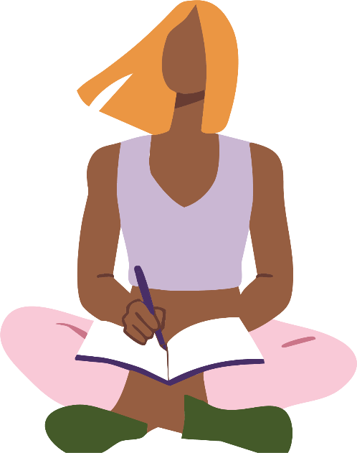

Getting a Mental Health Treatment Plan
If you’ve never had one, a mental health treatment plan can sound scary and more complicated than it is. Learning that I didn't need to meet specific “criteria” to talk to my GP about my mental health helped me feel confident to take the first step to find support.

What it actually is
Through Medicare, it gives me access to up to 10 free or subsidised sessions with a mental health professional a year7. Working as a team with my GP, it outlines the support I need and the goals I want to work on7.

How I got mine
I booked an appointment with my GP. When I booked, I let the clinic know I wanted to discuss a mental health plan, and selected a longer appointment so I had time to talk about how I was feeling7. I was nervous walking in, but once I’d said everything out loud, I felt relief - like I finally had a plan instead of trying to carry it all by myself.

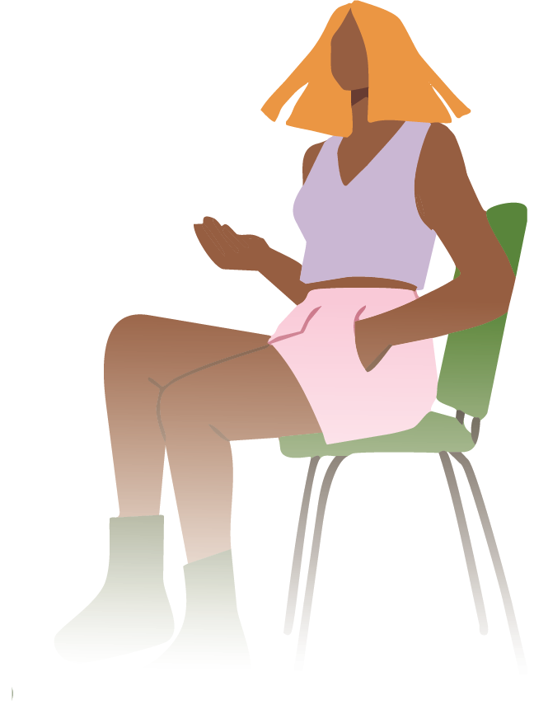

Where I Can Go Support in Gippsland
We now have a Mental Health and Wellbeing Local in East Gippsland and a Mental Health and Wellbeing Local in Latrobe. They support people aged 26+ and you don’t need a Medicare card, a mental health plan or a referral – you can just walk in.
In Baw Baw and Wellington we have Head to Health hubs. These hubs provide free mental health support, and you don’t need a Medicare card, Australian citizenship, a referral or an appointment to access them.
For South Gippsland and Bass Coast, South Gippsland Hospital and Bass Coast Health both offer free counselling services.
Young people aged 12-25 can access free mental health support through Headspace centres across Gippsland.
For First Nations people, Yarning SafeNStrong offers free and confidential counselling via a 24/7 helpline.
And if you are unsure what support is right for you, you can contact Medicare Mental Health. This free service can help connect you to the right support, and you don’t need a referral or a mental health plan to access the service.

References
- Beyond Blue, Women's mental health - Beyond Blue
- Jean Hailes, Unpacking the mental load: practical strategies to rebalance the scales - Jean Hailes
- Victorian Women's Health Atlas, Victorian Women's Health Atlas
- Better Health Channel, Stigma, discrimination and mental illness | Better Health Channel
- Beyond Blue, How to tell if someone has poor mental health - Beyond Blue
- Lifeline, Self-care for mental health and wellbeing | Lifeline
- Health direct, Mental health treatment plan | healthdirect

Self-Care Mapping Exercise
What are some actions you can take to support your wellbeing?
Feel free to complete this activity at your own pace, you are welcome to focus on only one or two areas listed below or whatever feels comfortable for you.

- What can you do at home?

- What can you do at work / in your community?

- What can you do inside?

- What can you do outside?

Remember self-care is a journey and looks different for everyone. It’s important to take time to find what works for you so it can become part of your routine, just like brushing your teeth.

Access This and Other Resources Online
Read this resource online, access alternative formats, or explore other
Say Yes To You resources on midlife, menopause and heart health on our website.

Stay In Touch
Follow us on social media
@GippslandWomensHealth
or visit www.gwhealth.asn.au
Contact us: gwhealth.asn.au/contact/

This resource was developed with support from The Latrobe Health Services Foundation.

