Menopause is a
normal part of ageing!
  - Here’s what I wish I’d known
(and what I’ve learnt along the way).

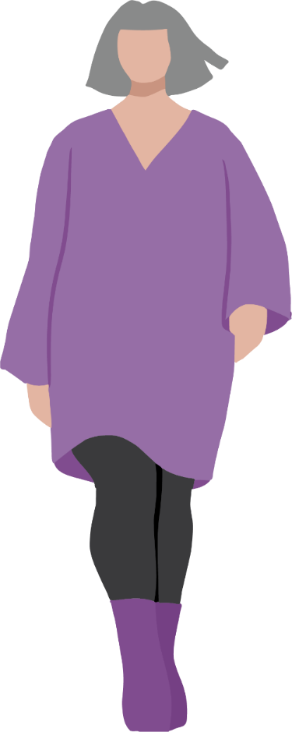
Note: We understand that every woman and gender diverse person's experience of health is different. Within this booklet we have endeavoured to ensure the information provided is relevant for our community, however we acknowledge that the content may not be reflective of all experiences. Please note that this booklet uses a first person narrative to communicate health information and is not the depiction of any specific individual's experience.

Table of Contents
What is menopause? 2
Perimenopause 2
Menopause 3
Post‑menopause 3
What menopause has looked and felt like for me 3
ADHD and menopause 4
Bone health 4
Mental health 4
Getting support 4
Booking an appointment 5
Preparing for my appointment 5
Advocating for myself 6
Learning more 6
References 6
Access This and Other Resources Online 7
Stay In Touch 7

What is menopause?
Menopause happens in three stages, and honestly, I didn’t realise how much it would shape my day-to-day life until I was in the thick of it1.

Perimenopause
This is where changes in hormones may lead to symptoms1. Perimenopause usually starts in your 40s (but can start earlier) and lasts for four to six years2. For me, this stage felt like little surprises appearing out of nowhere. One month everything was normal, and the next I found myself wondering why I was suddenly awake at 3am for no reason.

Menopause
This is technically just one day, 12 months since my last period1. I remember thinking, “Oh… so that’s it?”.

Post‑menopause
This is the time after menopause and for the rest of our lives1. This is the stage I’m in now, where things have mostly settled, but I’m still learning what my “new normal” feels like.
Most people reach menopause around 51, but anywhere between 45 and 55 is completely normal1.

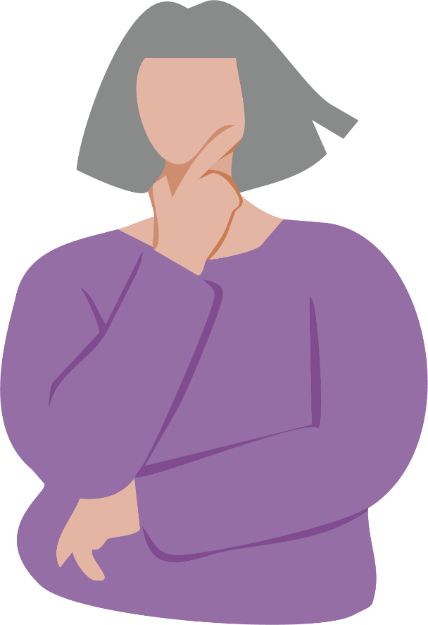

What menopause has looked and felt like for me
No two women experience menopause the same way. What surprised me most was how many different symptoms can show up1.
- Irregular periods - mine would vanish, then come back fully
- Hot flushes - I once had one in the supermarket freezer aisle and still felt too warm
- Night sweats - keeping an extra set of pjs nearby was a tip I wish I learnt sooner
- Trouble sleeping - I became well-acquainted with the 4am birds
- Mood swings - I once cried because my tea bag broke
- Anxiety and low mood
- Brain fog - occasionally walking into a room and forgetting why
- Aches and pains
- Bladder changes - getting up several times during the night because I needed to wee3
- Vaginal changes - such as vaginal dryness meant I regularly started to feel discomfort, irritation and burning sensations3
- Sex life - low sex drive, difficulty becoming aroused and/or difficulty having an orgasm4
When I first started experiencing symptoms, I often felt embarrassed and found it hard to talk about what I was going through, but speaking to a professional helped me find support that suited me best.

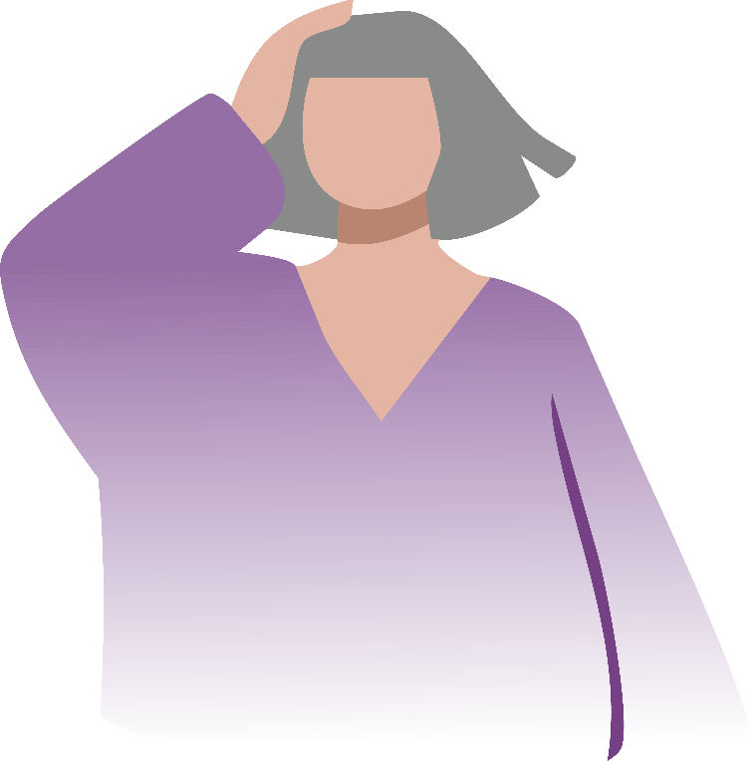

ADHD and menopause
A close friend of mine has ADHD, and she said menopause hit her like a double whammy, her usual symptoms felt louder and harder to manage5. Her doctor explained that changes in oestrogen levels may have amplified her ADHD symptoms6. By finding support, her symptoms became much more manageable. I have also heard of women who didn't know they had ADHD get a diagnosis during menopause6. For me, while I don’t have ADHD, I definitely noticed extra days where everything felt harder to keep track of.

Bone health
After menopause, oestrogen drops, and bone loss speeds up7. I remember my GP explaining that this increases the risk of osteoporosis and thinking, “Great. Another thing to add to the list”7. But knowing helped, now I’m more mindful about my calcium and exercise.

Mental health
This was the part I wasn’t prepared for, along with the physical changes of menopause I also experienced mental and emotional changes8. There were days I felt unlike myself – more irritable, more sensitive, or just flat. Once, I burst into tears because I couldn’t decide what to cook for dinner. It wasn’t really about the dinner… just hormones doing their thing.

Getting support
One of the best things I did was reach out for help. Menopause can feel overwhelming, but I realised I didn’t have to just “push through”.

Booking an appointment
I talked to my GP, and when I felt I needed more specialised support, I looked into women’s health clinics like the EACH Virtual Women’s Health Clinic who have 45 minute menopause appointments. Taking that first step made everything feel less confusing.
In Gippsland, we also have Latrobe Community Health Service, South Gippsland Hospital and Clinic 281, who provide dedicated sexual and reproductive health services like menopause support. And services like the Women's Health Clinic through Latrobe Regional Health specialise in care for early or complex menopause. This gives me confidence knowing I can get help locally.
I also recently learnt that Medicare has introduced subsidised health assessments for menopause and perimenopause9. These assessments go for at least 20 minutes and aim to support symptom management, lifestyle factors and long-term health risks such as osteoporosis and heart disease9.
Tip: I always try to book a longer appointment, because nothing is worse than watching the clock when you’re trying to explain symptoms that feel all over the place.

Preparing for my appointment
What can help:
- Keeping a symptom diary – even quick notes
- Writing down questions beforehand because, let’s be honest, brain fog is real
- Taking a notebook to appointments so you can make notes
The Jean Hailes symptom checklist is a good starting point – it can help make sense of what is happening.
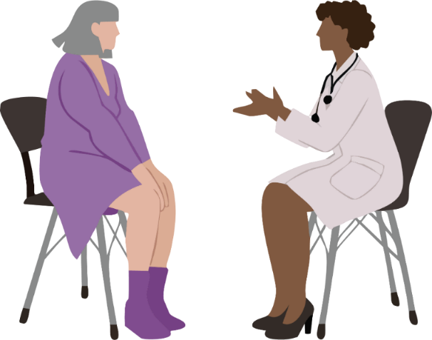

Advocating for myself
This was a big one. I’ve learnt that:
- I know myself best, if something feels off don’t let anyone tell me otherwise, even about things that feel awkward
- It’s okay to ask more questions
- And it’s definitely okay to get a second opinion, I need to do what is right for me.
I also started bringing someone with me to appointments when I felt nervous – just having another pair of ears helped me remember the details later.

Learning more
Along the way, I found a few trusted resources really helpful:
- Jean Hailes – Women’s health information and resources
- EACH Virtual Women’s Health Clinic – Virtual Women’s Health Clinic
- Beyond Blue – Perimenopause, menopause and mental health
They helped me understand what I was going through and reminded me that everything I was experiencing was normal, that support is available and I’m not alone.

References
- Jean Hailes, Menopause: Symptoms, Causes And Management | Jean Hailes
- Health Direct, Perimenopause | healthdirect
- Better Health Channel, Menopause and sex | Better Health Channel
- Australasian Menopause Society, Will Menopause Affect my Sex Life? | Fact Sheet | Australasian Menopause Society Hub
- Dr Louise Newson, ADHD and hormones in women
- Attention Deficit Disorder Association, ADHD and Perimenopause/Menopause: How Symptoms Overlap and Tips to Manage - ADDA - Attention Deficit Disorder Association
- Menopause Alliance Australia, Bone health in menopause - Menopause Alliance Australia
- Beyond Blue, Perimenopause, menopause and mental health - Beyond Blue
- Medicare Benefits Schedule (MBS) Online, MBS Online - Menopause and perimenopause health assessment services

Access This and Other Resources Online
Read this resource online, access alternative formats, or explore other Say Yes To You resources on midlife health, heart health, and mental health on our website.

Stay In Touch
Follow us on social media
@GippslandWomensHealth
or visit www.gwhealth.asn.au
Contact us: gwhealth.asn.au/contact/

This resource was developed with support from The Latrobe Health Services Foundation.

