Heart Health
  - What I need to know as a woman

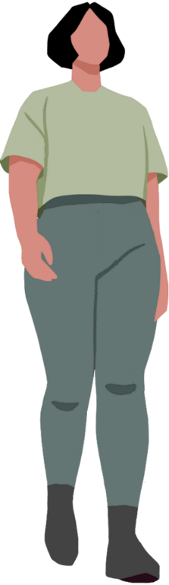

Note: We understand that every woman and gender diverse person's experience of health is different. Within this booklet we have endeavoured to ensure the information provided is relevant for our community, however we acknowledge that the content may not be reflective of all experiences. Please note that this booklet uses a first person narrative to communicate health information and is not the depiction of any specific individual's experience.

Table of Contents
Heart health where I live 2
My own heart health turning point 4
Understanding the symptoms I might have 4
Unique risk factors as a woman 5
What I can do to support my heart health 6
Being proactive: booking a heart health check 7
What the heart health check actually is 7
What happens at a heart health check 7
Remember 7
How I find support and information 8
Resources 8
Access This and Other Resources Online 9
Stay In Touch 9

One Australian woman dies almost every hour from heart disease1.
Heart disease affects a lot more women than many of us realise. It’s often seen as a “men’s issue”, but it’s actually the second leading cause of death for Australian women and something we should all be aware of2.

Heart health where I live
Living in Gippsland adds another layer. As Gippsland women, we have higher rates of heart disease compared to Victorian women3. Part of the reason is we don’t always have heart specialists close by, so things can get missed or take longer to sort out.
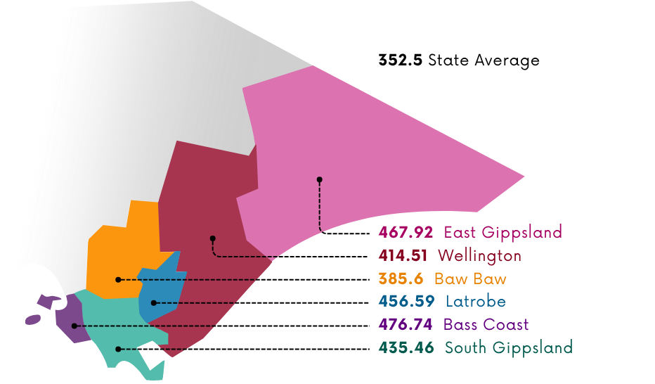
Figure 1: The rates of women diagnosed with heart disease per 10,000 women (as at August 2021)
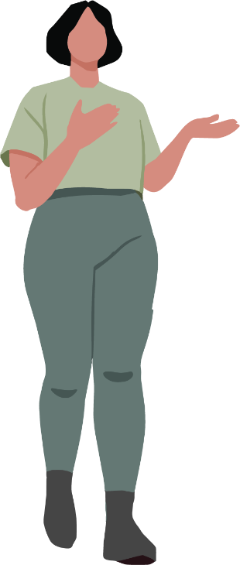

My own heart health turning point
A few years ago, I had a moment that made me take my heart health seriously.
I kept feeling this strange tightness in my chest and a kind of heaviness in my jaw
— nothing dramatic, just enough to make me pause. I brushed it off for weeks,
assuming it was stress, that I’d slept funny, or that I just needed more water.
But one morning, while walking up a hill near my house, I found myself unusually short
of breath. Even then, I hesitated. I didn’t think of a heart issue because I didn’t fit the picture I had in my head. Eventually, I booked a GP appointment.
Everything worked out okay, but that experience was a turning point. It made me realise
two things:
- women’s symptoms can often go unnoticed
- and I cannot afford to ignore my body when something feels off

Understanding the symptoms I might have
Both men and women can have the “classic” heart attack symptoms4:
- chest pain
- shortness of breath
- indigestion, nausea, vomiting
- a cold sweat
- dizziness
- tiredness
But as a woman, I can also experience symptoms
that don’t immediately scream “heart problem,” like4:
- discomfort in my jaw, neck, arm, shoulder, or back
If you are experiencing symptoms of a heart attack, do not delay seeking help, call Triple Zero 000.
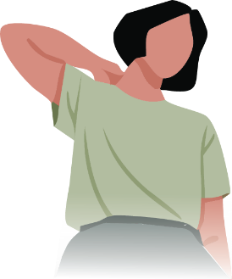

Unique risk factors as a woman
Smoking, low levels of exercise and an unhealthy diet are risk factors that impact both men and women5. However, as a woman, there are additional factors that increase my likelihood of heart disease, such as4,6:
- pregnancy complications
- menopause, especially early menopause
- irregular or absent periods
- starting my period at a young age
- previous breast cancer treatments
- taking the pill
- PCOS – Polycystic ovary syndrome
- autoimmune disease
- hormone treatments
- anxiety or depression
Learning how these connect to heart
disease helped me make sense of my experience.
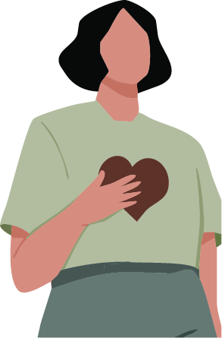
What I can do to support my heart health
These are the things I try to stay on top of now4,7:
- staying active in ways I enjoy
- eating a balanced diet
- managing alcohol intake
- caring for my mental wellbeing
- getting regular GP check‑ups
- keeping an eye on things like blood
pressure, cholesterol, and blood sugar
- quitting smoking or vaping (this is not an easy process, but with planning and support this can be achieved)
Small regular steps make a big difference.
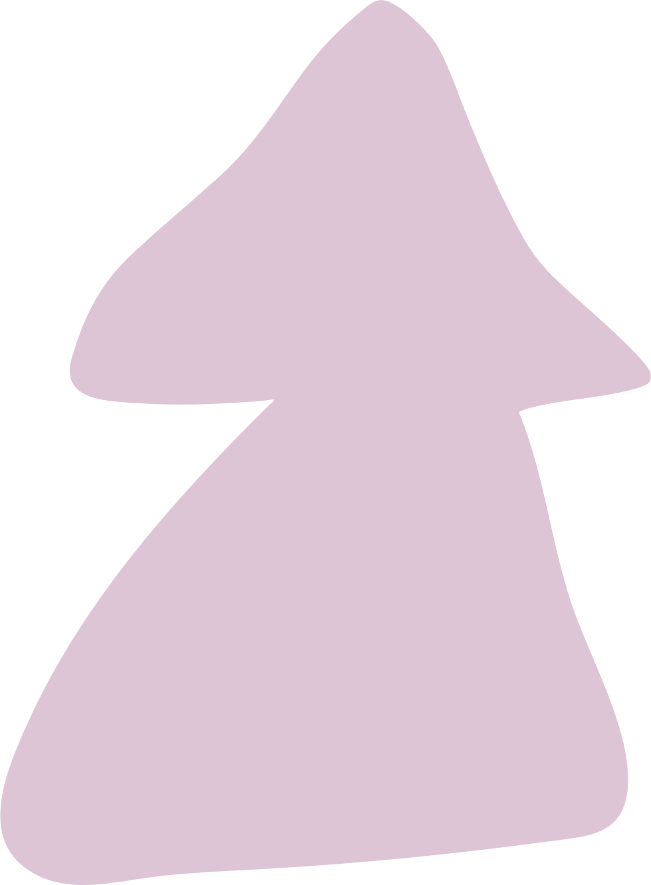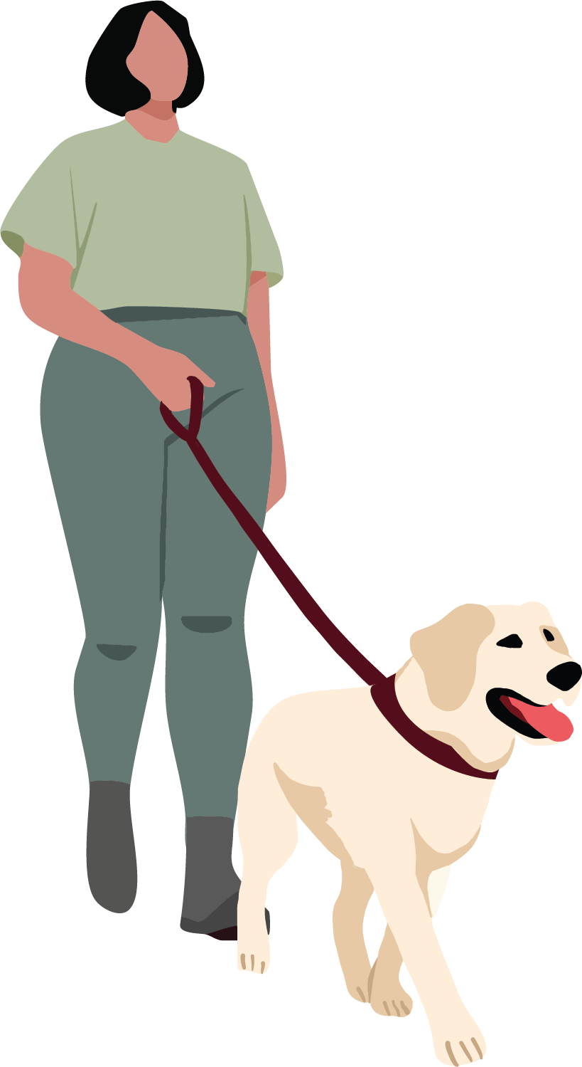

Being proactive: booking a heart health check
One of the best things to do is to start by getting a heart health check.
These checks should start at8:
- 45+
- 35 if you have diabetes
- 30 if you are a First Nations woman

What the heart health check actually is
A heart health check is a 20‑minute appointment with my doctor8. It’s covered by Medicare and free at clinics that bulk bill (you can check this by calling ahead before booking)8. I know in Gippsland it can be difficult to access GPs and wait times can often be long9. Where possible, I try to book well in advance.
It gives me a clear picture of my risk of heart attack or stroke in the next five years8.

What happens at a heart health check
Checks can involve4,8:
- talking about my medical and family history
- discussing my diet, activity level, weight, smoking or alcohol use
- getting my blood pressure, cholesterol and blood sugar levels checked

Remember
I know myself and my body best.
If something feels “off”, I need to reach out for support - even if it feels small or easy to dismiss.
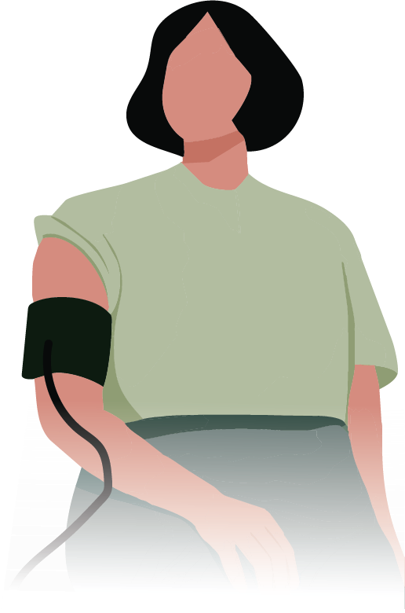

How I find support and information
To book a heart health check, I can find a GP through Health Direct – Healthdirect Australia is the national virtual public health information service.
And when I’m searching online, I try adding “women” to my search for example, “women’s heart health”, because women’s symptoms and risks are often different.

Resources
- Heart Foundation, Women and heart disease | Heart Foundation
- Australian Institute of Health and Welfare, Deaths in Australia, Leading causes of death - Australian Institute of Health and Welfare
- Victorian Women’s Health Atlas, Victorian Women's Health Atlas
- Jean Hailes, Heart Health & Cardiovascular Disease In Women | Jean Hailes
- Heart Foundation, Key statistics: Risk factors for cardiovascular disease | Heart Foundation
- Heart Foundation, Cardiovascular disease risk factors and heart attack warning signs in women | Heart Foundation
- Heart Foundation, Keeping your heart healthy | Heart Foundation
- Heart Foundation, Time to book a Heart Health Check? | Heart Foundation
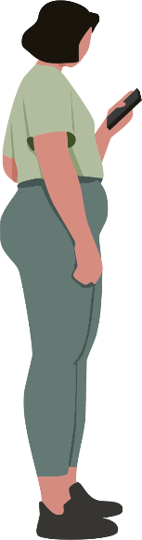
- Gippsland Women’s Health, Healthy Women Healthy Gippsland

Access This and Other Resources Online
Read this resource online, access alternative formats, or explore other Say Yes To You resources on midlife health, menopause health, and mental health on our website.

Stay In Touch
Follow us on social media
@GippslandWomensHealth
or visit www.gwhealth.asn.au
Contact us: gwhealth.asn.au/contact/

This resource was developed with support from The Latrobe Health Services Foundation.

